**Modifications to the DIS Summaries Lists Report to Display FDA approval information and Drug Type information (**[**OCECDR-4878**](https://tracker.nci.nih.gov/browse/OCECDR-4878)**)**

Here’s a screenshot of the current report interface: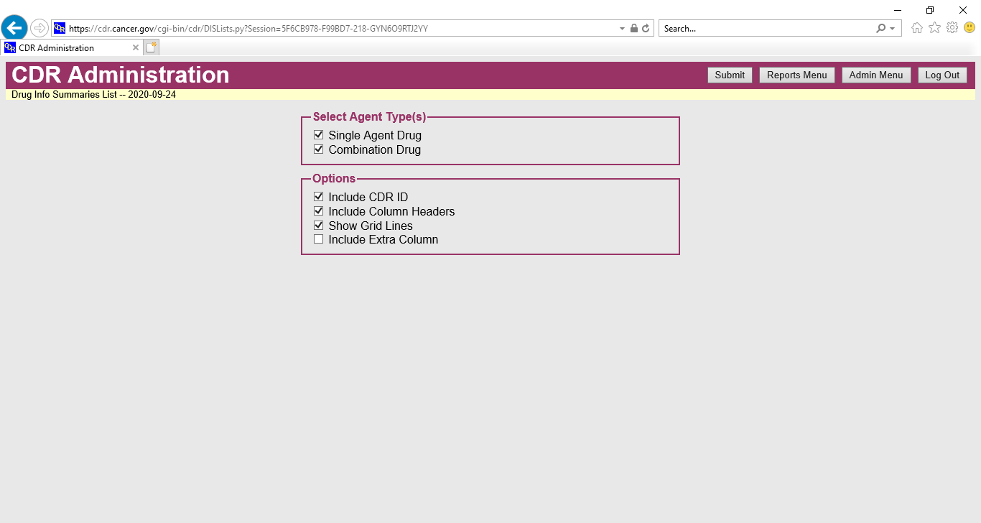

To this interface, we would like to add the following options:

1. In a new box labeled **Select FDA Approval Status**, please add “Accelerated approval” and “Approved in children”. These checkboxes (unselected by default) should limit the results to only those with the accelerated approval and/or approved in children attributes on the FDA approval element in the DIS.
2. Within the **Options** section, please add a new option to “Include FDA Approval Information”. If this is selected (please leave this option unselected by default), we’d like to add two new columns to the report:
   1. **Accelerated** (with “Yes” in the row beside drugs that have the accelerated approval attribute in the DIS).
   2. **Approved in Children** (with “Yes” in the row beside drugs that have the approved in children attribute in the DIS).
3. In a new box labeled **Drug Type**, please add a picklist with each of the values of the new Drug Type element listed. One or more drug types could be chosen from the list. No types should be selected by default. These values are listed below. Selecting a type(s) will limit the results of the report to DIS of that type(s). Please add a column labeled “Drug Type” with the type(s) listed in the row beside each DIS.

Chemotherapy

Hormone therapy

Immunotherapy

Targeted therapy

Radiotherapeutic

Supportive care therapy

Antiangiogenesis agent

Cancer treatment vaccine

Cancer prevention vaccine

CAR T-cell therapy

Enzyme inhibitor

Immune checkpoint inhibitor

Monoclonal antibody

Small-molecule drug

Other